Znakový komparátor

comparator.vhd
library IEEE;
use IEEE.std_logic_1164.all;
use IEEE.std_logic_unsigned.all;
entity Comparator is
port(
CLK: IN std_logic;
RST: IN std_logic;
DATA: IN std_logic_vector(6 downto 0);
CNT: OUT std_logic_vector(2 downto 0)
);
end entity Comparator;
architecture Comparator_arch of Comparator is
-- Sem doplnte deklarace vnitrnich signalu pro komunikaci
-- mezi jednotlivymi bloky obvodu. Jako priklad je uveden
-- signal vystupu registru, na zaklade jehoz zmeny je
-- spousten proces cmp_proc (viz sensitivity list tohoto
-- procesu).
signal pre: std_logic_vector(6 downto 0);
signal cmpout: std_logic; --cystup comparatoru
---------------------------------------------------------
begin
-- Zde doplnte kod procesu popisujiciho komparator.
cmp_proc: process(DATA, pre)
begin
if (pre > DATA) then --predchozi pismenko je vyssi nez soucasne
cmpout <= '1'; --ano
else
cmpout <= '0'; --ne
end if;
end process cmp_proc;
-- Zde doplnte kod procesu popisujiciho registr.
reg_proc: process(CLK, RST)
begin
if (RST = '1') then --asynchronni reset
pre <= "0000000"; --ascii ma 7 bitu
elsif (CLK'event and CLK = '1') then --nabezna hrana
pre <= DATA; --uloz vstup
end if;
end process reg_proc;
-- Zde doplnte kod procesu popisujiciho citac.
cnt_proc: process(CLK, RST)
variable RES: std_logic_vector(2 downto 0); --vysledek (RESult)
begin
if (RST = '1') then --asynchronni reset
RES := (others => '0');
elsif (CLK'event and CLK = '1' and cmpout = '1') then --nabezna hrana a komparator
RES := RES + 1; --plus 1
end if;
CNT <= RES; --ulozeni vysedku
end process cnt_proc;
end architecture Comparator_arch;

comparator_tb.vhd
library IEEE;
use IEEE.std_logic_1164.all;
entity TB_Comparator is
end entity TB_Comparator;
architecture TB_Comparator_arch of TB_Comparator is
constant period: time := 10 ns;
component Comparator is
port(
CLK: IN std_logic;
RST: IN std_logic;
DATA: IN std_logic_vector(6 downto 0);
CNT: OUT std_logic_vector(2 downto 0)
);
end component Comparator;
-- Vnitrni signaly test benche
signal clk: std_logic := '0';
signal rst: std_logic := '1';
signal data: std_logic_vector(6 downto 0);
signal cnt: std_logic_vector(2 downto 0);
begin
-- Sem doplnte instanci komponenty Comparator a namapujte
-- jeho vstupy a vystupy na vnitrni signaly test benche.
uut: Comparator
port map (
CLK => clk,
RST => rst,
DATA => data,
CNT => cnt
);
---------------------------------------------------------
clk <= NOT clk after period / 2;
TB_proc: process
begin
-- Sem doplnte prirazeni testovacich dat na vstupy obvodu.
-- Pro inspiraci je uvedena deaktivace resetu po uplynuti
-- doby k nabezne hrane hodin a vzorove prirazeni ASCII
-- hodnoty znaku X na datovy vstup obvodu. Povsimnete si,
-- ze v deklaracni casti test benche byl reset implicitne
-- nastaven na hodnotu '1'.
wait until clk'event AND clk = '1';
rst <= '0'; --odresetujeme
-- X K A L A B 0 0
-- 1011000 1001011 1000001 1001100 1000001 1000010 0110000 0110000
data <= "1011000"; --X
wait until clk'event AND clk = '1';
data <= "1001011"; --K
wait until clk'event AND clk = '1';
data <= "1000001"; --A
wait until clk'event AND clk = '1';
data <= "1001100"; --L
wait until clk'event AND clk = '1';
data <= "1000001"; --A
wait until clk'event AND clk = '1';
data <= "1000010"; --B
wait until clk'event AND clk = '1';
data <= "0110000"; --0
wait until clk'event AND clk = '1';
data <= "0110000"; --0
wait until clk'event AND clk = '1';
wait; --stuj
---------------------------------------------------------
end process TB_proc;
end architecture TB_Comparator_arch;

Časový diagram simulace
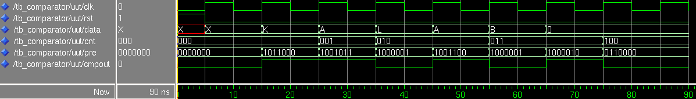XKALAB00

Protokol
proj01.pdf

